**Objectives**

* Design an internet topology featuring two Ethernet networks connected by a router.
* Include some other features

**A - Create the Topology**  
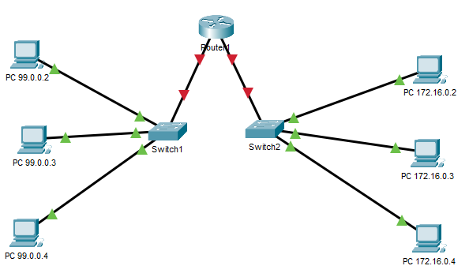

* Add a textbox with your name, Class ID , and “LAB 07B”
* Note: Use a 4331 Router and 2960 Switches
* Create two networks: 99.0.0.0 and 172.16.0.0
* Configure each PC’s IP address. *Important: we are not configuring any PC with an address of x.x.x.1. That address we are reserving for the router!*
* Add a router and connect with straight-through cables to each switch:   
   Switch0 to G0/0/0 and Switch1 to G0/0/1
* NOTE: Routers ports, by default, are SHUTDOWN. Do what you need to bring them back up.

**B – Configuring the router**

* The ports on the router must be given an IP addresses which will be the GATEWAY ROUTER address used by all devices on each network
* On the router, enter the specific configuration mode for port g0/0/0
* Enter the command: ip address 99.0.0.1 255.0.0.0
* On the router, enter the specific configuration mode for port g0/1
* Enter the command: ip address 172.16.0.1 255.255.0.0
* For each device on the 99.0.0.0 network, on its IP CONFIGURATION screen update the DEFAULT GATEWAY address to 99.0.0.1
* For each device on the 172.16.0.0 network, on its IP CONFIGURATION screen update the DEFAULT GATEWAY address to 172.16.0.1

**C – Testing Your Internet**

* Enter simulation more, clear all filters except IMCP
* Use the SIMPLE PDU to ping from all devices on the ‘10’ network to all devices on the ‘11’ network.
* Ensure you have full connectivity! *NOTE: Devices need to learn the IP addresses. Pings and broadcasts may fail the first or second time you do them, so repeat them as necessary.*

**D – Adding Another Network**

* We will now enter another network: 192.168.*yourclassid*.0   
  For example: I would create 192.168.162.0

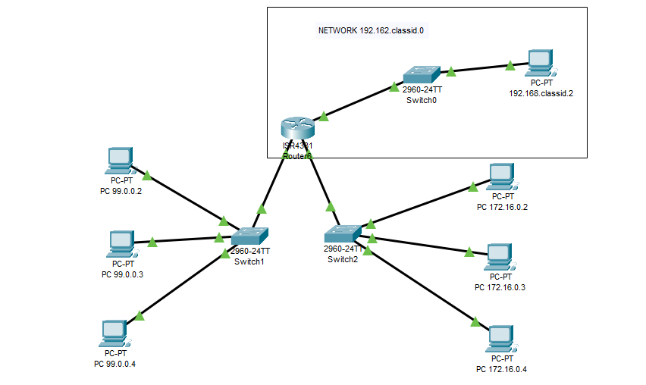

* To cable interface g0/0/2 we need to add a module to the router
  + Save the current configuration so that when we power off/on the configuration is set to the current state.
  + Add a GLC-T module in the bottom right slot  
    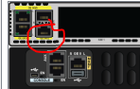
  + You should now be able to cable into the G0/0/2 port
* Configure the PC, switch and Router so that all PC’s can ping each other.

**D – Lab Completion**

* Add a textbox for new commands this module.
* Add a textbox and answer this question: How many PC’s will the new network support?
* Save your PKT file : L07B-lastname.PKT.
* Submit only the PKT file in iLearn. *You do not have to write up a lab for this week.*